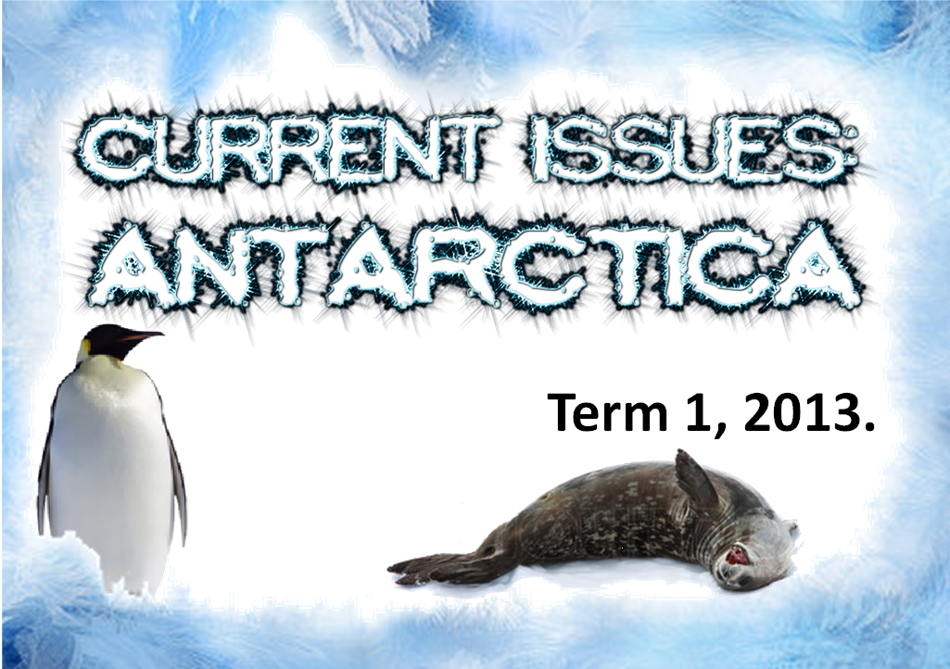

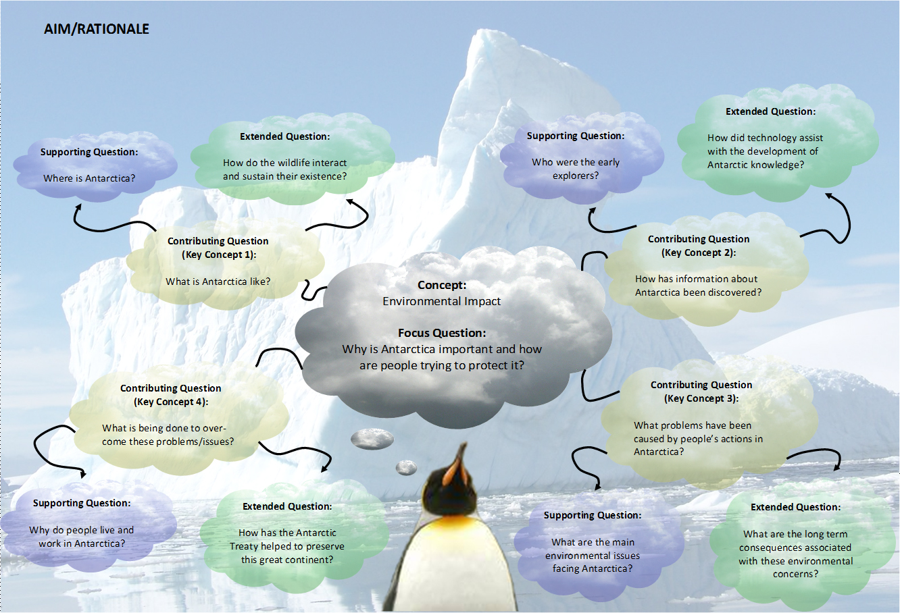

Pretest:
Students will create a mindmap about what they know about Antarctica – environment, exploration, issues and protection.

Antarctica Stage 3

Key Concept 1: What is Antarctica like?
Outcomes:
ENS3.6 Explains how various beliefs and practices influence the ways in which people interact with, change and value their environment.
LT S3.3: Identifies, describes and evaluates the interactions between living things and their effects on the environment.
UT S2.9 Selects and uses a range of equipment, computer-based technology, materials and other resources with developing skill to enhance investigation and design tasks.

 | Learning Intention | Whole Class Learning | Independent / Guided Learning |  | Plenary /  Assessment | QTP/Thinking Tools | Resources
Lesson Sequence 1 | Core  To describe and represent the location and environment of Antarctica  Extended  To illustrate the the environment through their own representations. | Discuss the location of Antarctica and locate on a world map/globe.  Use Google Earth to view satellite images of Antarctica. From the images discuss:  - How would you describe the environment?  - What would the seasons be like?  Investigate temperature patterns on Bureau of Meterology website.  Watch media introducing the Antarctic environment. (Life in the Freezer DVD)  Introduce Antarctica website design challenge – http://s3antarctica.weebly.com | Introduce the tasks for the About Antarctica page. Explain that students may select which two tasks they complete and use on their webpage.  Task 1 - Create a digital image and use as a header image on your website.  Task 2 - Create a photographic slideshow of at least 15 images, located using a creative commons search website, that gives an overview of Antarctica.  Task 3 - Create a fact sheet page for your website that gives an overview of Antarctica.  Task 4 - Create a labelled map of Antarctica that identifies the major locations and territory lines.  Task 5 - Create a junior non-fiction book about Antarctica and upload it or link it to your website.  Guide students through setting up their own weebly webpage before they begin the tasks. |  | Students upload/embed their completed tasks onto their webpage.  Have students identified and included the most important information about Antarctica through their chosen tasks?  Have students researched widely?  Were students able to upload/embed their tasks onto their own webpage? | Student Self Regulation  Student Self Direction  Engagement  Connectedness | Life in the Freezer DVD  BoM website  All website design related resources are located on the class website
Lesson Sequence 1 |  |  | Support  Provide examples and scaffolds to guide students. | Extension  Tasks vary in difficulty and allow students to extend themselves through extra research or enhanced presentation and choice of program.
Lesson Sequence 2 | Core  To identifiy and describe the types of wildlife that live in the Antarctic.  Extended  How do the wildlife interact and sustain their existence? | Brainstorm as many different types of wildlife that live in the Antarctic.  Record in notes or pages app on the ipad or on paper.  Watch media introducing the animals of the Antarctic.  Edit list of animals as necessary. Ensure full animal names are used e.g. Emperor penguin as opposed to penguin.  Conduct further research online or by reading.  Create a word cloud of Antarctic animals using completed list.Save and upload to own website. | Introduce the tasks for the Antarctic Wildlife page. Explain that students may select which task they complete and use on their webpage.  Task 1 - Create an animoto about the wildlife of Antarctica.  Task 2 - Create a multimedia poster about a specific Antarctic animal.  Task 3 - Create an animation depicting a food chain of the Antarctic.  Task 4 - Create a junior non-fiction book about the wildlife of the Antarctic.  Task 5 - Create a video with the purpose of delivering information about a chosen Antarctic animal. |  | Students upload/embed their completed tasks onto their webpage.  Were all animals of the Antarctic identified in the word cloud?  Have students identified and included the most important information about their selected animal in their chosen task?  Have students researched widely?  Were students able to upload/embed their tasks onto their own webpage? | Student Self Regulation  Student Self Direction  Engagement  Connectedness | All website design related resources are located on the class website  Life in the Freezer DVD  Arkive website  Tagxedo site  Word Cloud app
Lesson Sequence 2 |  |  | Support  Provide examples and scaffolds to guide students.  Provide students with a variety of reading resources in differing ability levels. | Extension  Tasks vary in difficulty and allow students to extend themselves through extra research or enhanced presentation and choice of program.

Key Concept 2: How has information about Antarctica been discovered?
Outcomes:
ENS3.6 Explains how various beliefs and practices influence the ways in which people interact with, change and value their environment.
UT S2.9 Selects and uses a range of equipment, computer-based technology, materials and other resources with developing skill to enhance investigation and design tasks.

 | Learning Intention | Whole Class Learning | Independent / Guided Learning |  | Plenary /  Assessment | QTP/Thinking Tools | Resources
Learning Sequence 1 | Core  Identifies the main explorers and describes their achievements involved in Antarctic exploration.  Extension  Talks about how lack of preparation and new technologies played a role in these expeditions. | Discuss:  The quest to be the first to the South Pole was a very significant event in Antarctic history.  Who were the main explorers in the early 1900s who attempted to reach the pole?  What do we know about Shackleton, Scott and Amundsen?  How were the similar? How were they different?  In groups of three students work to complete a retrieval chart comparing the explorers and their expeditions.  View: The Race to The South Pole article and see rare photographic and video footage from the Amundsen expedition. | Introduce the tasks for the Antarctic Explorers page. Explain that students may select which task they complete and use on their webpage.  Task 1 - Create a voki for Scott, Amundsen, Shackleton and Mawson.  Task 2 - Map out the journeys of either Shackleton’s Endurance voyage or Amundsen’s and Scott’s journeys to the South Pole.  Task 3 - Interview an explorer, record and embed.  Task 4 - Create an interactive timeline showing significant events in the history of the Antarctic. |  | Completed retrieval chart.  Were students able to work together to teach each other about their explorer? | BROW – Brainstorm, Read, Organise, Write.  Social Support  Knowledge Integration  Narrative | ‘Race to the Pole’ by Meredith Hooper  All website design related resources are located on the class website  Retrieval chart  Internet access  ‘Amazing Antarctica’ teacher resource
Learning Sequence 1 |  |  | Support  Provide examples and scaffolds to guide students. Provide students with a variety of reading resources in differing ability levels | Extension  Students are presented with a variety of tasks and a variety of ways to prepare and present them.
Learning Sequence 2 | Core  Can describe the purpose of Antarctic expeditions even after the race to the South Pole was won.  Extension  Explains how technology developments assisted in the explicit mapping of Antarctica. | Discuss:  Why do you think explorers kept returning to Antarctica even after the race to the South Pole had been won?  Watch Voyage of Endurance  View the timeline for the entire voyage and rescue mission.  Douglas Mawson set out to explore and map the coastline of Antarctica.  Read about why Mawson went to Antarctica and the outcome of his expedition on the Mawsons Huts and Mawson Museum websites.  What happened in 1928 that saw land expeditions on Antarctica all but cease?  How did the invention of the aeroplane assist in discovering what was still unknown in Antarctica?  Read Antarctic Cartography by Jess Ericson | Continue with your selected website task.  Task 1 - Create a voki for Scott, Amundsen, Shackleton and Mawson.  Task 2 - Map out the journeys of either Shackleton’s Endurance voyage or Amundsen’s and Scott’s journeys to the South Pole.  Task 3 - Interview an explorer, record and embed.  Task 4 - Create an interactive timeline showing significant events in the history of the Antarctic. |  | Students upload/embed their completed tasks onto their webpage.  Have students identified and included the most important information about their selected explorer in their chosen task?  Is there evidence of wide reading?  Were students able to upload/embed their tasks onto their own webpage? | Engagement  Social Support  Student Direction  Connectedness | Mawson’s Huts  Mawson’s Huts Foundation Museum website  NOVA website  Antarctic Cartography by Jess Ericson (pdf)  All website design related resources are located on the class website
Learning Sequence 2 |  |  | Support  Provide examples and scaffolds to guide students. Provide students with a variety of reading resources in differing ability levels | Extension  Students are presented with a variety of tasks and a variety of ways to prepare and present them. |  | Engagement  Social Support  Student Direction  Connectedness

Key Concept 3: What problems have been caused by people’s actions in Antarctica?

Outcomes:
ENS3.6 Explains how various beliefs and practices influence the ways in which people interact with, change and value their environment.
LT S3.3: Identifies, describes and evaluates the interactions between living things and their effects on the environment.
UT S2.9 Selects and uses a range of equipment, computer-based technology, materials and other resources with developing skill to enhance investigation and design tasks.
 | Learning Intention | Whole Class Learning | Independent / Guided Learning |  | Plenary /  Assessment | QTP/Thinking Tools | Resources
Learning Sequence 1 | Core  Students can identify the major environmental issues effecting Antarctica.  Extended  Students can make reasonable predictions about possible consequences if these issues are not addressed.  . | Discuss:  Why is there an ongoing human presence in Antarctica?  Investigate the different reasons for human involvement in Antarctica - mineral exploration; tourism; ecological research; meteorological  research; explorers; whaling; fishing; possible military involvement.  As a result of these interactions, how has Antarctica’s environment been effected?  What are the major issues?  Global Warming  Ozone Depletion  Ocean Acidification  Whaling, Sealing & Fishing  Habitat Destruction  Tourism  Water Pollution  Introduced Species  Waste management  Select an issue and then pair up and explain consequences of the issue. | Introduce the tasks for the Environmental Issues page. Explain that students may select which task they complete and use on their webpage.  Task 1 - Write a letter to a member of parliament expressing your concern for the Antarctic, addressing one issue in particular.  Task 2 - Create a podcast, vodcast or write a rap about an issue that threatens Antarctica.  Task 3 - Design a presentation for visitors to Antarctica to watch before they arrive. |  | Students upload/embed their completed tasks onto their webpage.  Have students identified an issue that threatens Antarctica?  Have they demonstrated an understanding of the impact of this action/issue and explained possible consequences?  Were students able to upload/embed their tasks onto their own webpage? | ITPE – Identify  Think, Pair, Explain  Social Support  Problematic Knoeldge  Higher Order Thinking  Substantive communication | AAD website  Cool Antarctica  Classroom Antarctica  All website design related resources are located on the class website
Learning Sequence 1 |  |  | Support  Provide examples and scaffolds to guide students. Provide students with a variety of reading resources in differing ability levels | Extension  Students are presented with a variety of tasks and a variety of ways to prepare and present them.

Key Concept 4: What is being done to overcome these problems/issues?

Outcomes:
ENS3.6 Explains how various beliefs and practices influence the ways in which people interact with, change and value their environment.
LT S3.3: Identifies, describes and evaluates the interactions between living things and their effects on the environment.
UT S2.9 Selects and uses a range of equipment, computer-based technology, materials and other resources with developing skill to enhance investigation and design tasks.
 | Learning Intention | Whole Class Learning | Independent / Guided Learning |  | Plenary /  Assessment | QTP/Thinking Tools | Resources
Learning Sequence 1 | Core  Students can describe the purpose and main goals of the Antarctic Treaty and Madrid Protocol.  Extended  Students can clearly explain how the Treaty and Madrid protocol have helped to preserve Antarctica. | Discuss:  What is the Antarctic Treaty?  What is its main goal?  Do you think this is a good approach or not?  What issues doesn't the Antarctic Treaty address?  What is the main purpose of the Madrid Protocol?  How do these help protect Antarctica?  Split the class into two sides. Research and then debate the topic: Mining should be allowed in Antarctica. | Introduce the tasks for the Jobs in Antarctica page. Explain that students may select which task they complete and use on their webpage.  Task 1 - Write a series of diary entries that would depict what life might be like fulfilling a particular occupation in the Antarctic.  Task 2 - Apply for a job in the Antarctic.  Task 3 - Design your own new research station. |  | Debate  Were all students able to contribute to the debate, giving reasons and evidence to support their arguments?  Was an understanding of the Antarctic Treaty and Madrid Protocol exhibited during the debate? | Problematic Knowledge  Knowledge Integration  Narrative  Substantive communication  Deep Understanding | AAD website  Classroom Antarctica  All website design related resources are located on the class website
Learning Sequence 1 |  |  | Support  Provide examples and scaffolds to guide students. Provide students with a variety of reading resources in differing ability levels | Extension  Students are presented with a variety of tasks and a variety of ways to prepare and present them.
Learning Sequence 2 | Core  Students can discuss the purpose of research stations on Antarctica.  Extended  Explains how researchers/scientists might need to change their methods to comply with the Antarctic Treaty. | Explore Mawson’s Hut and Scott’s Hut via virtual tour.  Compare and contrast the two huts.  Research stations have now been built by many different countries. Review the map and discuss:  How many are located inland?  Why are most stations are located on the coastline?  Why are so many of them around the Antarctic Peninsula?  Who has the most wintering stations?  How many has Australia got?  What sort of jobs do you think people have at these stations?  Brainstorm and list. | Pairs of students are assigned one of the four major Australian research stations.  Research and create an information report about your allocated research base. Include information such as:  location, size, environment, main areas of research and nearby wildlife.  Continue working on your website task.  Task 1 - Write a series of diary entries that would depict what life might be like fulfilling a particular occupation in the Antarctic.  Task 2 - Apply for a job in the Antarctic.  Task 3 - Design your own new research station. |  | Students upload/embed their completed tasks onto their webpage.  Were students able to prepare an information report on their research station?  Have students identified a specific job that is undertaken in the Antarctic?  Have they demonstrated an understanding of the daily routines and responsibilities associated with this job?  Were students able to upload/embed their tasks onto their own webpage? | Self Direction  Self Regulation  Substantive Communication | Mawsons Huts website  AAD – Stations website  Station webcams  All website design related resources are located on the class website
Learning Sequence 2 |  |  | Support  Provide examples and scaffolds to guide students. Provide students with a variety of reading resources in differing ability levels | Extension  Students are presented with a variety of tasks and a variety of ways to prepare and present them. |  | Self Direction  Self Regulation  Substantive Communication

Post Test: Students create a new mind map outlining their new knowledge regarding the environment, exploration, issues and solutions. This can be compared to their initial mind map to determine new knowledge and understandings.

Literacy connections | Numeracy connections
- Information Report texts  - Persuasive texts  - Digital texts  - Oral discussions  - Group conversations/turn taking | - Position – mapping, coordinates  - Number – averages,  - Measurement – timelines, mass, length/distance, area,  - Data - graphing

